# Updated Strategy Optimization with SMA

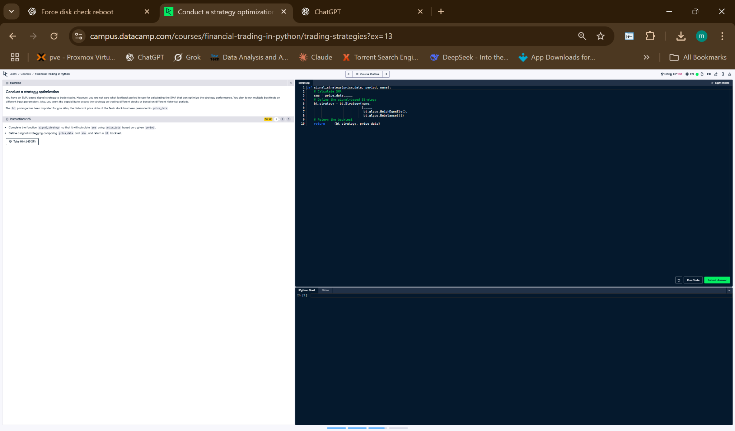

## Updated Python Code

def signal_strategy(price_data, period, name):  
 # Calculate SMA  
 sma = price_data.rolling(period).mean()  
  
 # Define the strategy  
 s = bt.Strategy(name,  
 [bt.algos.SelectWhere(price_data > sma),  
 bt.algos.WeighEqually(),  
 bt.algos.Rebalance()])  
  
 # Return the backtest  
 return bt.Backtest(s, price_data)

## Updated Explanation

This function calculates a simple moving average (SMA), then creates a strategy that picks stocks trading above their SMA. It assigns equal weight to selected stocks and rebalances the portfolio. The result is a backtest object used to evaluate the strategy’s performance.